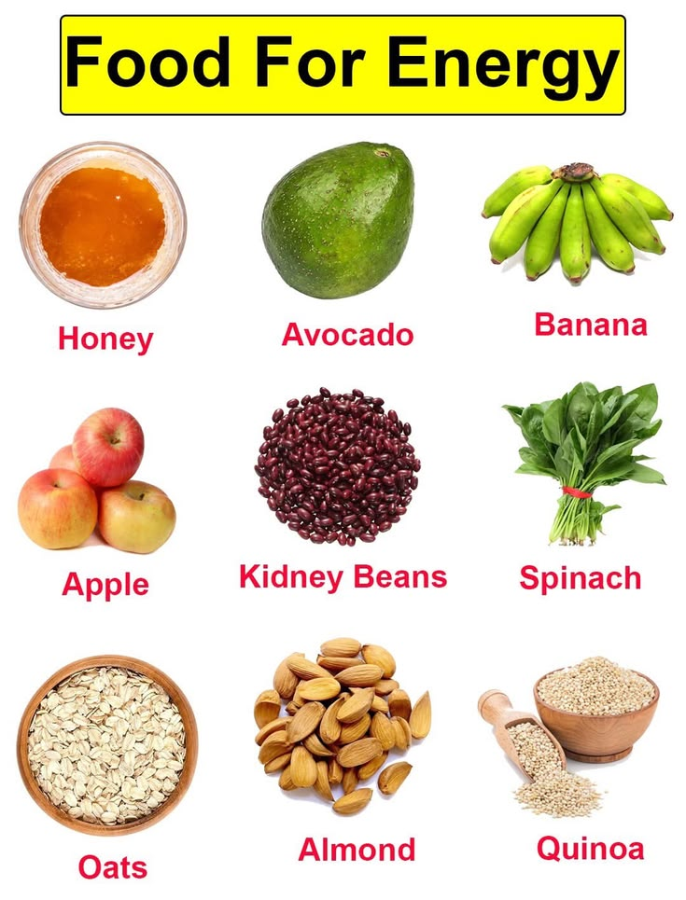
ENERGY GIVING FOOD

